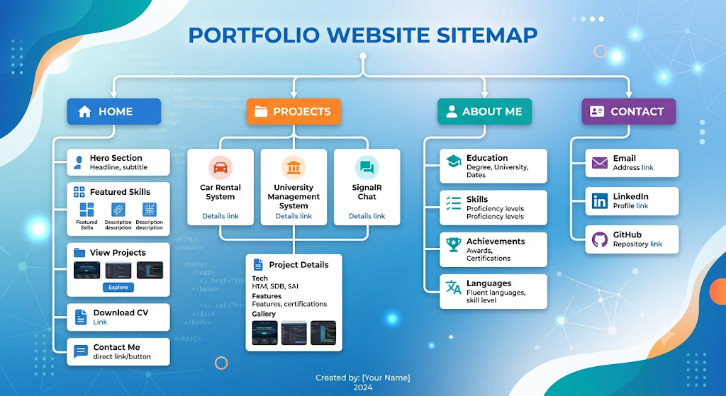
Portfolio Website
Home
- Hero Section - Featured Skills - View Projects - Download CV - Contact Me

Projects
- Car Rental System - University Management System - SignalR Chat - Project Details

About Me
- Education – Skills – Achievements - Languages

Contact
- Email – LinkedIn – GitHub

Perplexity:
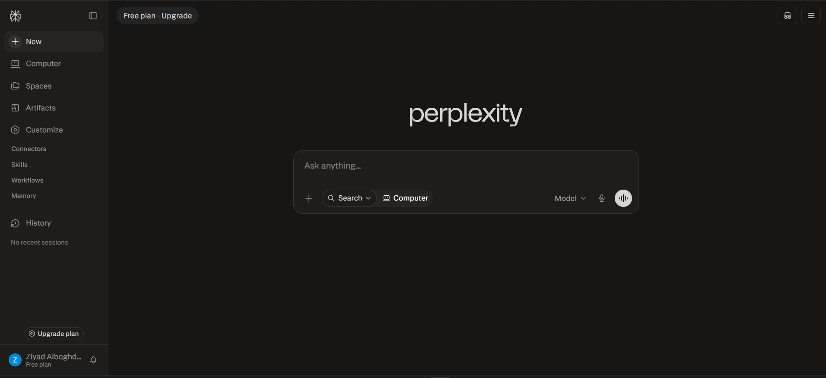
Chat gpt:
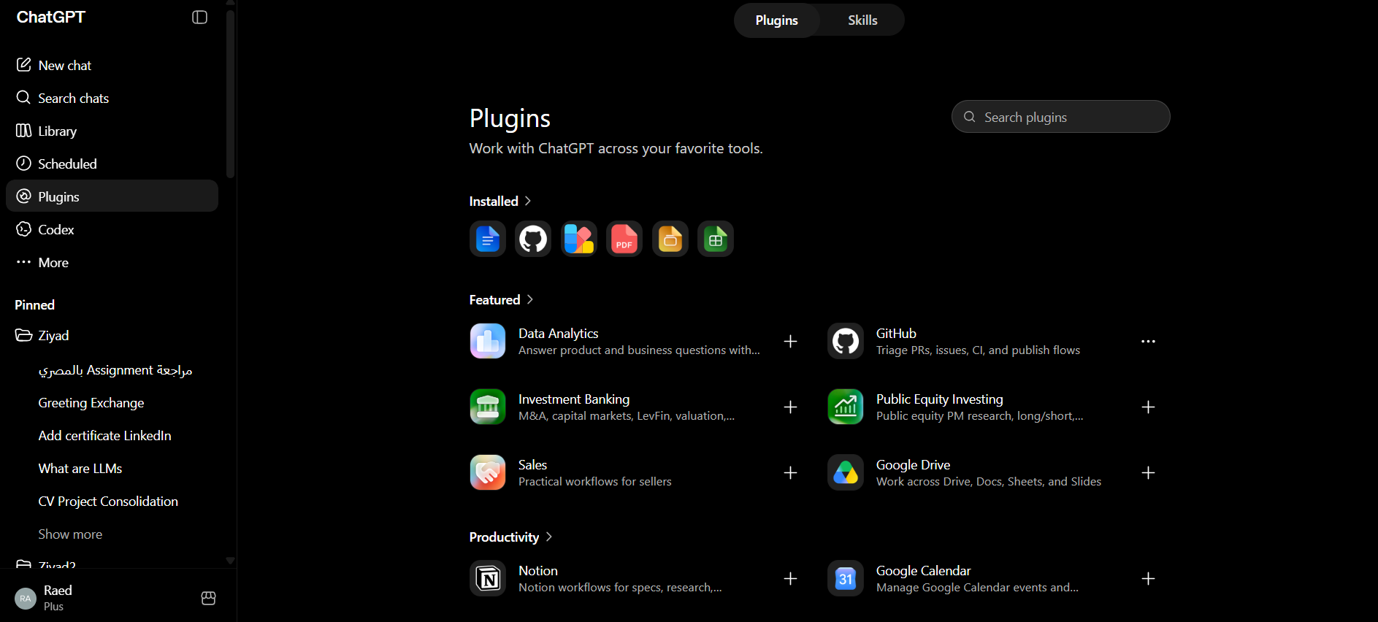

Gemini:
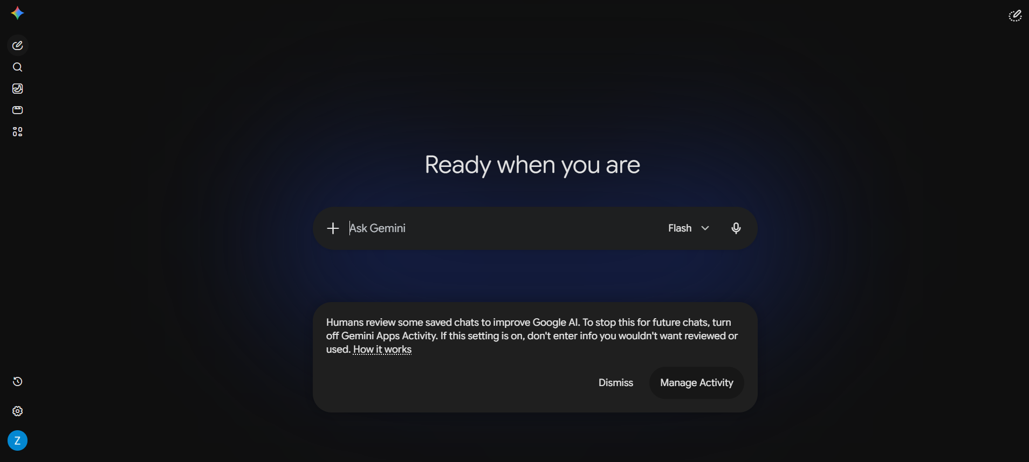

Claude:
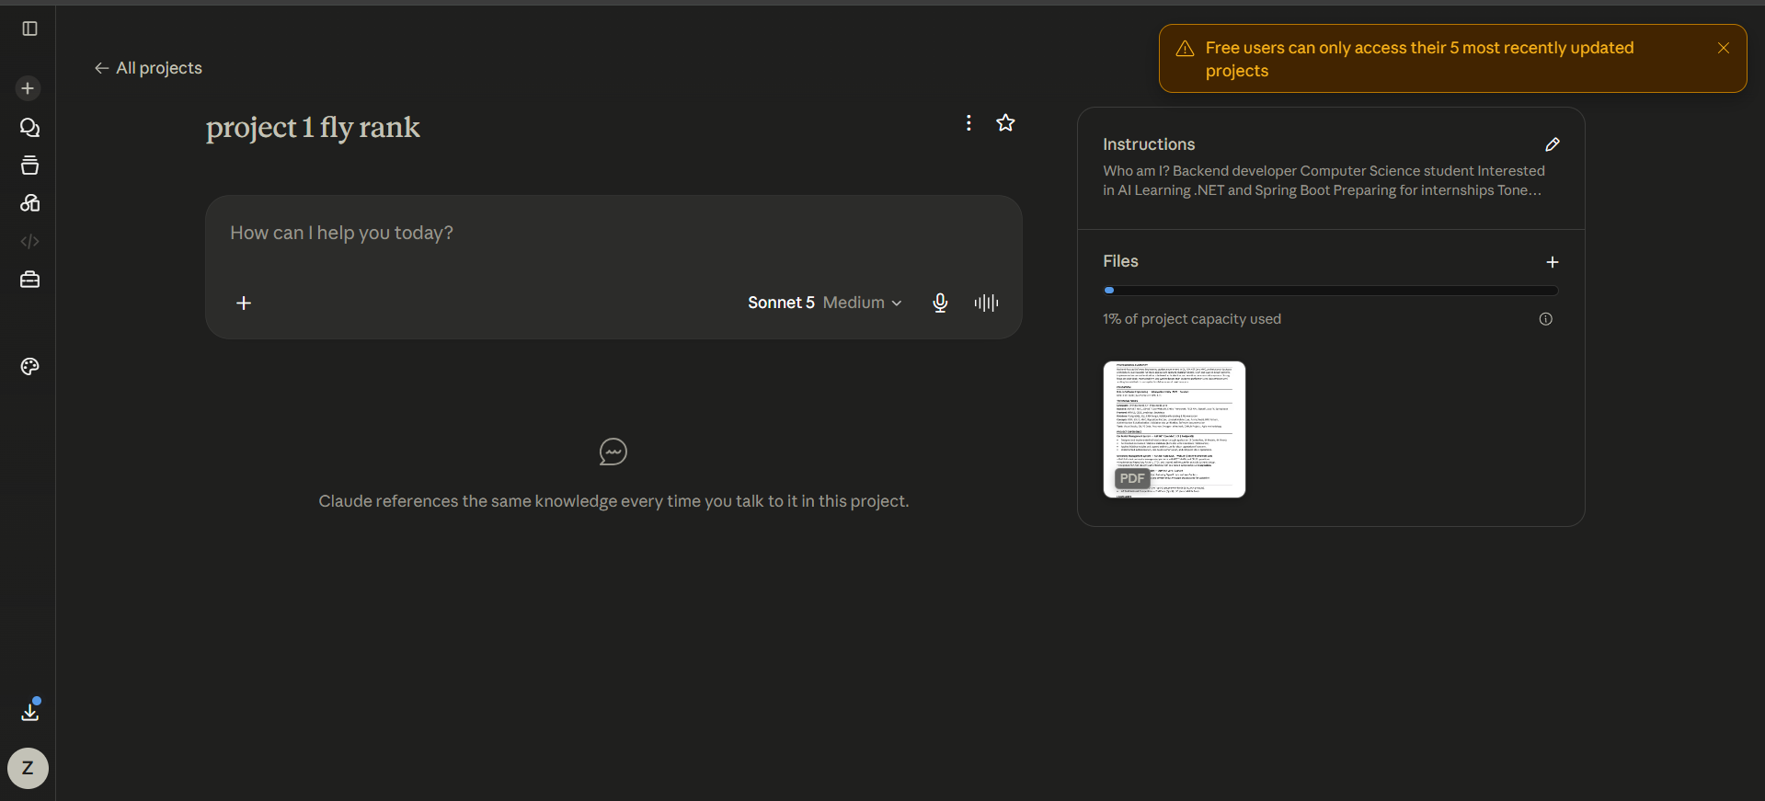

Enhancement after asking claude :
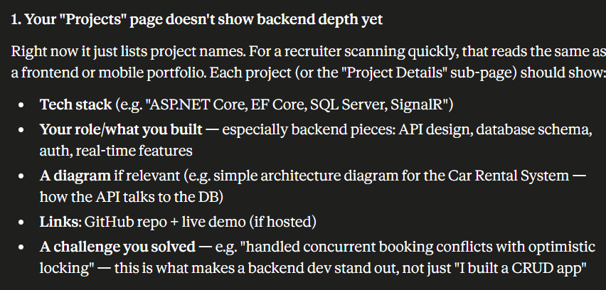

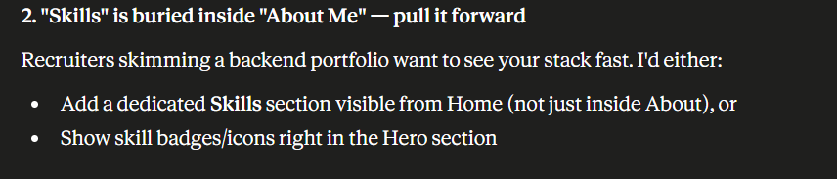

Revised structure:
Home → Hero (with tech stack badges), Featured Skills, Projects preview, CV download, Contact
Projects → Car Rental System → [detail page: stack, diagram, GitHub, demo, challenges]
→ University Mgmt System → [detail page]
→ SignalR Chat App → [detail page]
Skills → Languages, Frameworks, Databases, Tools (grouped)
About Me → Education, Achievements, Languages, "currently learning" note
Contact → Email, LinkedIn, GitHub, (optional: contact form)

